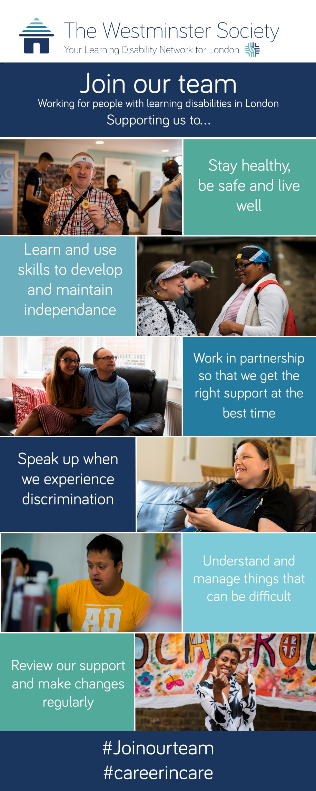

Become a Support Worker

The Westminster Society is an award winning charity with over 50 years’ experience supporting people with learning disabilities in London. As a support worker you will help people with learning disabilities to live safe, fulfilling and dignified lives in supported accommodation or their own home.

Join us at one of over 30 locations in Westminster, Camden, Islington and Kensington & Chelsea.

Salary £18,135 - £20,572 per year
Hours Full time, part time, day, night and flexible hours available

Read our story and apply for a job:
www.wspld.org.uk

Find out more information:
recruitment@wspld.org
020 8968 7376

What does the job involve?
As you are supporting people to live their life, you will find that no two days and no two people you support are the same, so you need to be ready for the unexpected!

Depending on their needs you the support you give could include helping people with:
- getting up and out of bed
- personal care – washing, going to the toilet
- preparing and eating food
- cleaning and laundry
- going shopping
- managing money
- going to health and other appointments
- attending college
- visiting friends or entertaining them when they visit
- undertaking leisure activities like going to the cinema or to a the zoo
- helping people to develop communication skills and friendships
- supporting any health needs, such as taking medication, recording relevant information and liaising with others.

How will you deliver this support?
To ensure your support is high quality, effective and delivered in a safe and stimulating environment, you will:
- involve our Service Users as much a possible when planning and doing those activities
- help our Service Users in meetings and social settings to ensure they are included, consulted and listened to
- help our Service Users to do things they want to do
- record things appropriately in logs and handovers
- ensure you tell your colleagues about anything they should know at the end of your shift so support continues seamlessly
- respect people’s dignity and property
- be alert to, challenge and report disrespectful behaviour, potential abuse and misconduct
- attend and participate in your induction, training sessions and meetings
- report any incidents or accidents that occur

How will we support you?
We will support you by giving you:
- a detailed induction so you will understand our Service Users’ expectations, your job and how to do it
- regular supervision, appraisal and feedback
- training on specific tasks and activities
- developmental opportunities, so you can develop your skills
- opportunities to apply for promotion within the Society
- generous holiday entitlement, that increases the longer you work for us
- an employee assistance scheme and occupational sick pay on successful completion of your probation.
If you have not already done so you will need to successfully complete a Level 2 Diploma in Health and Social Care within your probationary period of employment.

What experience and skills do you need for this job?
We don’t insist that you have done this type of work before, but if you have, or have done something similar, it is an advantage.

You will need to:
- share our values
- be caring
- communicate well
- be responsible
- be able

How do you apply?

You can attend one of your open days, these are held regularly at our Head Office and Training Centre in Queen’s Park

Download an application form from our website and return it to recruitment@wspld.org

Our expectations explained

Sharing our values means:
- you want to support people with learning disabilities
- you are friendly and enthusiastic
- you can work collaboratively with colleagues as part of a team
- you take pride in your work
- you are punctual.
Being caring means:
- you put the people we support first
- you are patient
- you can support people with positive behaviour
- you treat people with dignity and respect
- you carry out your job to the best of your abilities
- you can help people with limited communicate skills to be heard and understood
Communicating well means:
- you communicate respectfully
- you listen to people and consider what they say
- you speak and write clearly and accurately
- you have basic IT skills
- you can complete log books accurately and write reports of incidents etc.
- you solve problems with your colleagues in private
Being responsible means:
- you can work on your own and take decisions when necessary
- you can understand risk and danger and act to ensure people stay safe
- you can support service users with medication
- you responsibility for your own development, learning on the job and in formal settings
- you recognise and learn from your mistakes
Being able means:
- you are flexible and are able to deal with unexpected events
- you have basic maths skills
- you are willing to support people with personal care
- you are fit enough to accompany people around their community and where necessary push a wheelchair, use a hoist etc.
- you can work on a rota basis over 7 days, including early starts (7am), late finishes (10pm), weekends and sleep-ins. if the hours you can work are limited or you want more flexibility to choose your working hours you should apply for the sessional worker role
- you can pass our vetting checks

